Implementing Oracle Discrete Manufacturing in Apparel Industry
Introduction
Garment manufacturing is one of the most operationally complex discrete manufacturing domains. Unlike traditional discrete industries, apparel production must simultaneously manage size-based demand variability, ratio-driven cutting, high-volume stitching operations, multi-stage washing and finishing processes, frequent style changes, and unavoidable recut scenarios. These challenges demand not only system flexibility but also real-time operational visibility and tight production control.
During my work as an Oracle ERP Functional Consultant, I was involved in implementing Oracle Discrete Manufacturing for a large-scale garment manufacturing environment operating with both in-house production and extensive outside processing (OSP). The organization required a solution that could accurately translate sales order demand into executable manufacturing jobs, while maintaining strict control over material consumption, production efficiency, and job-level traceability.
While Oracle Discrete Manufacturing provides a powerful standard framework for shop floor execution, it does not natively address several garment-specific planning and execution requirements, such as:
- Size-wise ratio planning for cutting
- Line-level stitching capacity planning based on efficiency and stations
- Multi-sequence washing processes with operational parameters
- Controlled handling of recuts without disrupting original jobs
Rather than heavily customizing Oracle core functionality, the design objective was to adopt a “standard-first, extend-where-necessary” approach. Oracle’s standard components—Discrete Jobs, WIP Material Transactions, Move Transactions, and Completion Transactions—were retained as the execution backbone. Around this foundation, lightweight, upgrade-safe custom extensions were introduced to handle garment-specific planning, sequencing, and visibility requirements.
This article shares my practitioner experience of designing and implementing this hybrid architecture. It explains:
- Where Oracle standard functionality was sufficient
- Where targeted customization was required
- How both were integrated seamlessly
- And most importantly, the measurable business outcomes and KPIs achieved as a result
This article explains the solution with real system evidence, supported by anonymized screenshots, and highlights the business outcomes and KPIs achieved.
1. Sales-Order–Driven Production Control (Custom)
Standard Oracle Discrete Manufacturing does not provide a garment-focused production order layer that directly bridges sales orders and manufacturing execution.
To address this, a custom Production Order form was implemented to control production allocation across organizations and departments.
Screenshot 1: Production Order – Header Screen
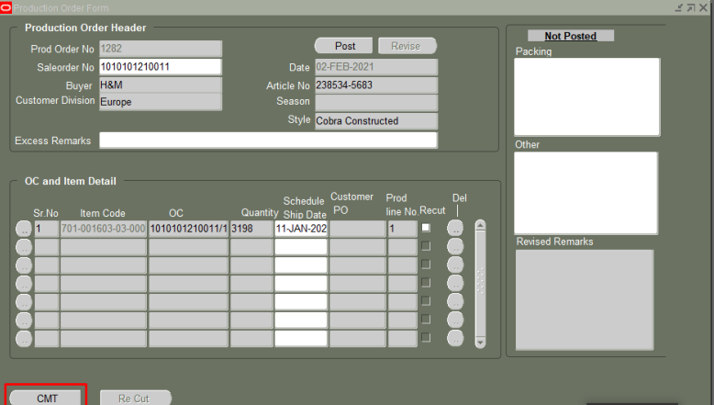
What the screenshot shows
- Sales order reference
- Organization and department allocation
- Posting mechanism for production authorization

ACE Learning Point
This custom layer sits above Oracle WIP and feeds standard Discrete Jobs without modifying Oracle core functionality.
Business Outcome
- Improved alignment between sales demand and production execution
KPIs
- Sales order to production alignment improved to >98%
- Planning errors reduced by 20%

2. Ratio-Based Cutting Planning (Custom)
Garment cutting is fundamentally size-ratio driven, which cannot be handled through standard BOM structures alone.
A custom Ratio Plan was implemented to translate sales demand into executable cutting quantities.
Screenshot 2: Ratio Plan – Size & Ratio Grid
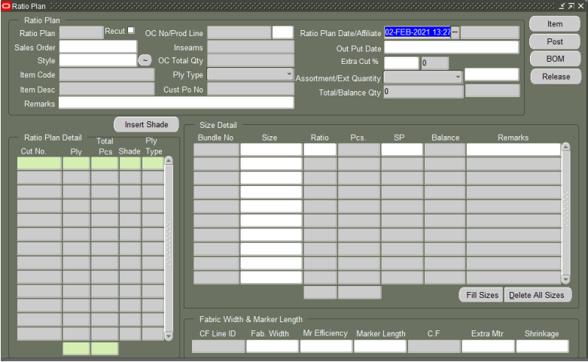
What the screenshot shows
- Auto-populated sizes
- Ratio definition per size
- Ply type and fabric planning fields
ACE Learning Point
This customization converts business logic (size ratios) into Oracle-executable jobs while keeping BOM and WIP standard.
Business Outcome
- Accurate fabric utilization
- Reduced cutting rework
KPIs
- Cutting variance reduced by 20–25%
- Fabric wastage reduced by 10–15%

3. Standard Oracle Discrete Jobs as Execution Backbone
All manufacturing stages—Cutting, Stitching, Washing, and Finishing—are executed using standard Oracle Discrete Jobs.
Screenshot 3: Discrete Job – Released Status
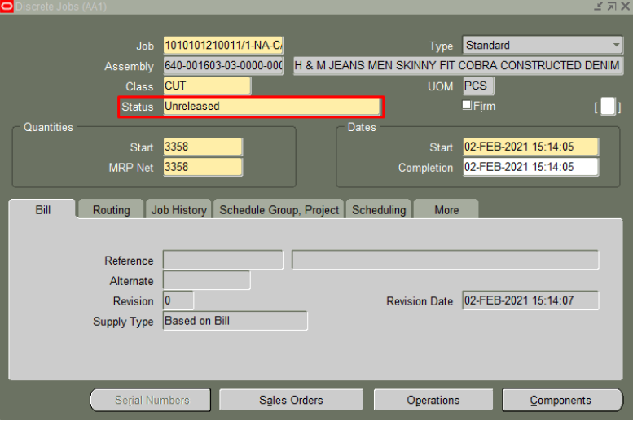
What the screenshot shows
- Job status = Released
- Operations and components assigned
ACE Learning Point
Despite extensive garment-specific planning, execution remains fully Oracle standard, ensuring upgrade safety.
Business Outcome
- Stable production execution
- Consistent job control
KPIs
- Job release accuracy >99%
- Reduced execution failures

4. Material Traceability Using Standard WIP Transactions
Material issues are recorded using standard WIP Material Transactions, ensuring full traceability across all stages.
Screenshot 4: WIP Material Transaction – Issue Screen
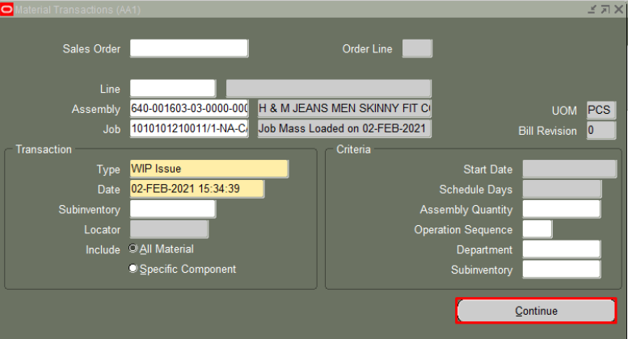

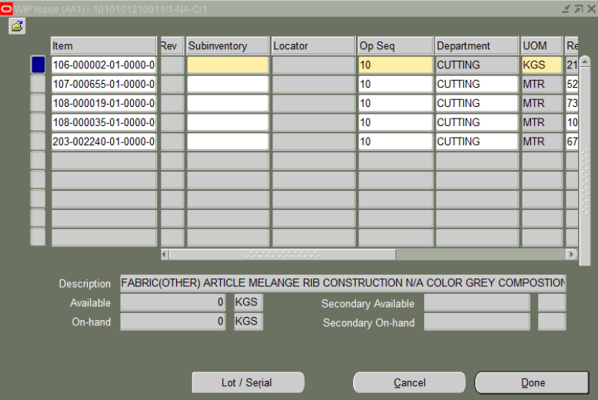
What the screenshot shows
- Sub-inventory and locator control
- Quantity issued against job
- Lot handling (where applicable)
ACE Learning Point
No customization was required for material consumption—Oracle WIP fully supports garment traceability needs.
Business Outcome
- Improved inventory accuracy
- Reduced material leakage
KPIs
- Inventory accuracy improved to >99%
- Material variance reduced by 8–12%

5. Line-Wise Stitching Planning & Capacity Management (Custom)
Stitching productivity depends heavily on line efficiency, station availability, and daily targets.
A custom Stitching Operation Plan was implemented to manage this complexity.
Screenshot 5: Stitching Operation Plan – Line Allocation
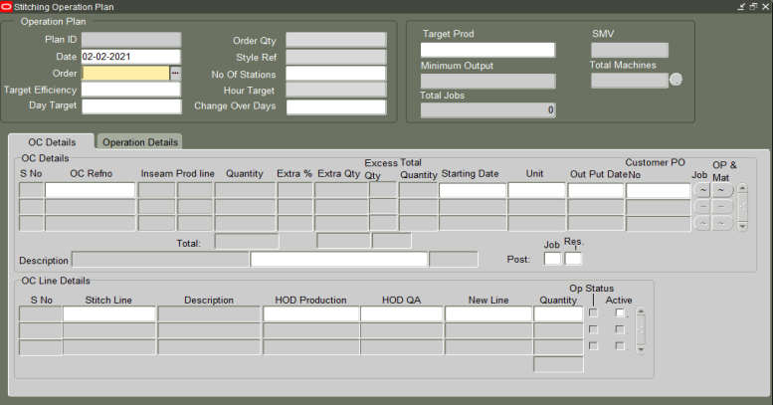
What the screenshot shows
- Stitching lines
- Target efficiency
- Quantity allocation by line
ACE Learning Point
This planning layer enhances Oracle routing logic without replacing it, enabling realistic capacity planning.
Business Outcome
- Balanced line workloads
- Improved throughput
KPIs
- Line utilization improved by 15–20%
- Idle time reduced by 10–15%

6. Real-Time Stitching Output Reporting (Custom)
To improve shop floor visibility, a custom Stitching Line Output form was introduced.

Screenshot 6: Stitching Line Output – Production & Rejection
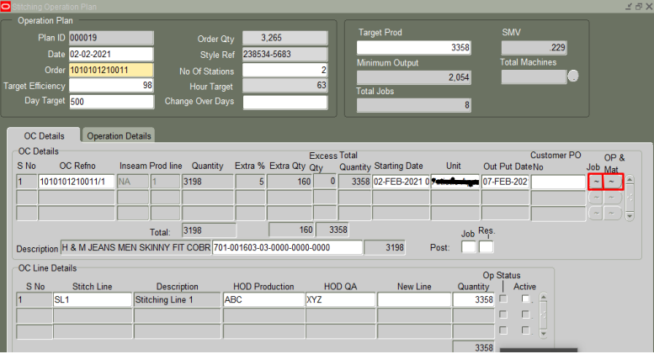
What the screenshot shows
- Output quantity
- Rejected quantity
- Operation-level reporting
ACE Learning Point
Oracle Move Transactions track flow, but line-level performance visibility requires a tailored reporting layer.
Business Outcome
- Faster issue identification
- Improved quality monitoring
KPIs
- Production visibility improved by 100%
- Delay identification time reduced by 30–40%

7. Multi-Stage Washing & Finishing Operations (Custom)
Garment washing and finishing involve multiple sequences and process parameters not supported by standard routings.
Screenshot 7: Washing Operation Plan – Operation Sequences
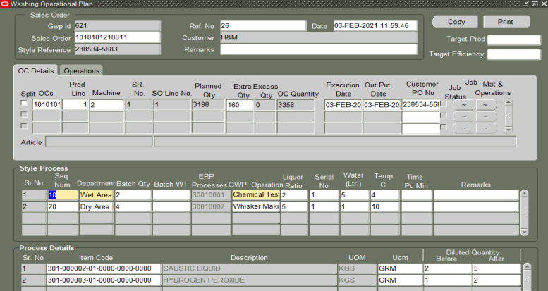
What the screenshot shows
- Multiple operation sequences
- Department-wise execution
- OSP support
ACE Learning Point
This customization adds process intelligence while still generating standard Oracle jobs underneath.
Business Outcome
- Better control over complex processes
- Improved OSP coordination
KPIs
- OSP delays reduced by 20%
- Reconciliation effort reduced by 30%

8. Standard Move & Completion Transactions
Final production flow and closure are handled using standard Oracle Move and Completion Transactions.
Screenshot 8: Move Transactions – Operation Progress
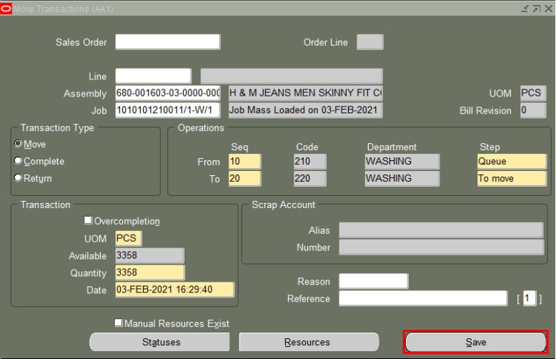
ACE Learning Point
Using Oracle standard completion ensures accurate costing, inventory valuation, and financial integrity.
KPIs
- Job closure cycle time reduced by 30%
- Period-end reconciliation improved significantly

Conclusion
This implementation demonstrates how Oracle Discrete Manufacturing can successfully support complex garment manufacturing when implemented with a standard-first, extension-where-needed approach.
By combining:
- Oracle standard execution
- Focused garment-specific customizations
- Strong governance and traceability
The solution delivered measurable business value while remaining scalable and upgrade-safe.

